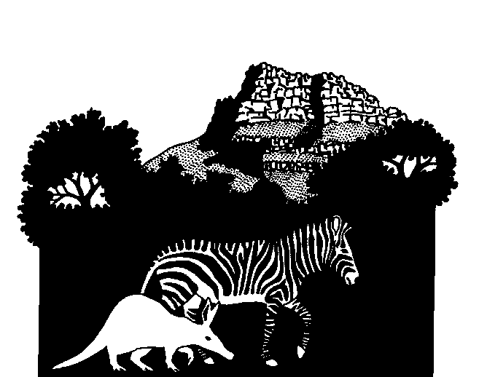

**CONSERVATION MANAGEMENT SERVICES – Ken Coetzee**

4 Chestnut Street, Heather Park,

George, 6529, South Africa

# Cell: +27 76 227 5056

**e-mail: consken@mweb.co.za**

**www.conservationmanagementservices.co.za**

29 September 2025

**Amendment of an Environmental Authorisation for a Beachfront Security Estate on Portion 66 & 67 of Farm 443, Plettenberg Bay, Western Cape.**

1. **INTRODUCTION**

Ken Coetzee of Conservation Management Services (CMS) was requested by Joclyn Marshall of Eco Route Environmental Consultancy to comment on the amendments to an Environmental Authorization for a Beachfront Security Estate on Portion 66 & 67 of Farm 443, Plettenberg Bay, Western Cape.

CMS had previously carried out an Animal Species & Terrestrial Biodiversity Assessment of the above property in January 2023. The findings of this evaluation are summarised below.

The following comments are based on the findings of the 2023 assessment and no further fieldwork was considered necessary at the site due to the nature and extent of the amendments.

**2. THE FINDINGS OF THE ORIGINAL ANIMAL SPECIES & TERRESTRIAL BIODIVERSITY ASSESSMENT, JANUARY 2023.**

Inventories for terrestrial fauna of the entire study site were drawn up from the literature. Each species identified was then evaluated in terms of the occurrence of its required habitat on the study site and then listed as likely to occur, a possibility to occur or unlikely to occur on the study site.

The Red Data listed species of each group were then also evaluated in terms of their occurrence on the study site in terms of habitat suitability. Animal species that were identified by means of the screening tool were also evaluated in terms of habitat suitability on the study site.

None of the red Data listed or the screening tool identified species were considered to occur on or even use the study site on a permanent basis. The study site habitats do not represent any kind of critical or specialized resource for any of the sensitive animal species or their habitats.

The natural habitats available on the study site are all anthropogenically impacted, to a variable degree, but the current situation is set to deteriorate swiftly due to the devastating impact of invasive alien *Acacia cyclops*, which in the last few years has already spread over half of the site and which will continue to spread and mature to the further detriment of all indigenous plant and animal species in the area.

It can thus be summarized with a high degree of confidence that the study site is of no importance to the fauna predicted by the screening tool to occur on it and that the other fauna on the site is already in an advanced state of decline due to habitat transformation.

1. **ENVIRONMENTAL AUTHORISATION (EA)CHANGES TO THE**

The proposed changes to the EA are as follows:

* The amendment of the Site Development Plan (“SDP”) to reflect a boardwalk instead of a footpath along the northern boundary.

* A revised layout proposed for the amendment of building plates that will have an overall increase in the development footprint of the building plates by 165m².

**3.1 THE RAISED BOARDWALK**

A raised boardwalk system is considered as having less impact on the dune system than a footpath as it allows for the establishment of some dune vegetation under the structure. It will also ensure that people wanting to access the beach are restricted to the boardwalk, therefore reducing potential erosion of the sandy substrate and trampling of the dune vegetation due to foot traffic.

A boardwalk minimizes the direct impact on sensitive dune ecosystems, reducing the trampling of plants and animal habitats. It preserves the natural dune structure, which helps maintain the dune's role in coastal protection (preventing erosion and acting as a barrier to storm surges).

Wooden boardwalks are generally more durable than footpaths, especially in areas with heavy foot traffic or in erosion-prone environments. They are less likely to become damaged by weather, erosion, or frequent use. Accoya modified wood is proposed to be used for the structure. This wood has a lifetime warranty of 50 years above ground and 25 years in the ground. Minimal maintenance will be required during the operational phase, thus reducing further impact through maintenance.

The only potential negative impact will be the planting of the boardwalk support poles into the substrate with concrete. This impact, however, will be minimal and a “once-off”, and preferable to the continuous trampling of the sandy route if not approved. An important positive of the boardwalk is that it obviates the need for people to walk off the route and over the dune covering vegetation.

Apart from the positive aspects of a boardwalk over the sandy substrate, the biodiversity assessment clearly found that the study site habitats do not represent any kind of critical or specialized resource for any of the sensitive animal species or their habitats. It can thus be stated that the proposed plan to include the boardwalk will not have a negative impact on the biodiversity or stability of the site.

**3.2 REVISED DEVELOPMENT LAYOUT**

An adjustment in the building plate layout and an increase in build plate area by 165m² is required due to the consolidation of Stand PO7 and PO6. The building plate adjustment also includes an additional area on PO8 and reduction of PO9. The build plate for PO9 has been reduced by 71m², and PO8 increased by 54m² resulting in a

reduction of the total build plate area for the two stands by 17m².

These modifications to the building plate will have no negative impact on the biodiversity of the site due to fact that the natural habitats available on the study site are all anthropogenically impacted, to a variable degree (natural vegetation removal and invasion by *A. cyclops*). Apart from past anthropogenic impact the biodiversity assessment clearly found that the study site habitats do not represent any kind of critical or specialized resource for any of the sensitive animal species or their habitats.

It is thus concluded that the revised layout will not have a negative impact on the biodiversity of the site.

1. **SUMMARY**

It is concluded that the proposed changes to the Environmental Authorization will not have a negative impact on the biodiversity of the site and that the installation of the boardwalk will in fact have a long-term positive impact.